Nichole Shirell Press KIT

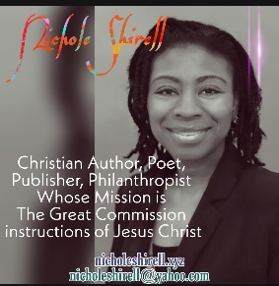

Nichole Shirell is from Birmingham Al. She is a woman who is actively chasing God's heart. Her desire is to share the gospel of Christ all over the world.

She is a Christian published author and poet of multiple books. She is an intercessor and evangelist whose mission is the Great Commission given by Jesus.

Nichole Shirell is the founder of Nichole Shirell Enterprise's publishing and consulting services. Their goal is to help writers publish bodies of work by helping to reduce anxiety and complexity often experienced while trying to bring work to written life.

In the summer of 2018, the company expanded and she formed the nonprofit division of the company which is comprised of 3 segments: youth ministry, prison ministry, and domestic violence survivors. Mission: inspire, motivated and love those who seek a voice.

The Great Commission
16 Then the eleven disciples left for Galilee, going to the mountain where Jesus had told them to go. 17 When they saw him, they worshiped him—but some of them doubted!
18 Jesus came and told his disciples, “I have been given all authority in heaven and on earth. 19 Therefore, go and make disciples of all the nations,[a] baptizing them in the name of the Father and the Son and the Holy Spirit.
20 Teach these new disciples to obey all the commands I have given you. And be sure of this: I am with you always, even to the end of the age.”
Matthew 28:16-20

Contact Nichole Shirell Enterprises
Web: Nicholeshirell.xyz
Email: NicholeShirell@yahoo.com
Follow Nichole Shirell: Facebook, Instagram, Twitter, Pinterest, Youtube, Periscope
Amazon Author’s Page: amazon.com/author/nicholeshirell

