Nichole Shirell

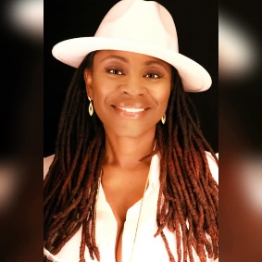

Nichole Shirell is from Birmingham Al. She is a woman who is actively chasing God's heart. Her desire is to share the gospel of Christ all over the world.
She is a Christian published author and poet of multiple books. She is an intercessor and evangelist whose mission is the Great Commission given by Jesus.
Nichole Shirell is the founder of Nichole Shirell Enterprise's publishing and consulting services. Their goal is to help writers publish bodies of work by helping to reduce anxiety and complexity often experienced while trying to bring work to written life.
In the summer of 2018, the company expanded and she formed the nonprofit division of the company which is comprised of 3 segments: youth ministry, prison ministry, and domestic violence survivors. Mission: inspire, motivated and love those who seek a voice.

Nichole is the owner of Visionaries Agency Empire LLC (VAE) is a social media talent management corporation. The business was established in February of 2020. The agency manages social media influencers (SMI) who share content on a global scale. The content of SMI talents varies and includes skills from artists, comedians, poets, rappers, singers, writers, entrepreneurs, socializers, and more.

2021 Projects:
​"Amplification" is one of the artist’s 2021 projects that shine a spotlight and calls for corrections of injustices that are still prevalent in our communities nationwide.
"Father to the Fatherless" is the final book of the trilogy: "Restoration, Redemption, Revitalization." The series concludes with important life lessons. The focus is on some of the unspoken truths our youth face or fights daily: such as unwanted advances, stalking, death of a parent, and grandparents who parent.

She is the mother of three young men and a new grandmother of one baby boy. She is currently mentoring her nephew and twelve-year-old protégé Nickadian Y, a poet who released his first chapbook, Summer 2019, and a coloring book fall of 2020.

Contact NSE or VAE

Web:
Nichole Shirell Enterprises Publishing Consulting Community Services (wixsite.com)
Email: NicholeShirell@yahoo.com
Follow Nichole Shirell: Facebook, Instagram, Twitter, Pinterest,
Youtube, Periscope
Amazon Author’s Page: amazon.com/author/nicholeshirell

Visionaries Agency Empires (VAE) LLC
Email: visionariesa@gmail.com
https://visionariesa.wixsite.com/visionariesae
Visionaries Agency Empire LLC (@VisionariesL) / Twitter
https://www.facebook.com/VisionariesAE/

